Patent Filing Document
Date of Filing: 3/31/2025

Patent Title
InterApp Arbitration System for Lock Screen Content Refresh

Abstract
The InterApp Arbitration System provides a method for managing content refresh access during lock screen events for competing applications. By evaluating priority, device performance, network type, and refresh limits, the system ensures fair access to the lock screen while preventing one app from monopolizing screen time. The system dynamically adjusts timing based on device conditions and network profiling, allowing both apps to cooperate and avoid conflicting refresh cycles.

Detailed Description
The invention consists of a system for dynamically managing content refresh access between two competing Android applications during a lock screen event. The system comprises the following key components:
- **Arbitration Manager**: Responsible for evaluating the refresh requests and determining which app should be granted access based on priority, network, and device conditions.
- **Network Profiler**: Evaluates whether the device is connected to Wi-Fi or carrier data, adjusting refresh duration based on network conditions.
- **Device Profiler**: Assesses the device's performance (e.g., RAM, CPU) and adjusts the refresh cycle duration for low-end devices, ensuring that high-end devices receive quicker refresh times.
- **Telemetry Logger**: Collects data on refresh requests, decisions made by the Arbitration Manager, and the performance of the apps during arbitration.
- **Config Manager**: Contains configuration settings for max refresh requests, priority values, and duration limits.
This system ensures that both applications can refresh their content fairly without causing interference, respecting device and network resources.

Claims
1. A method for managing content refresh access between competing applications during a lock screen event, comprising:
- Receiving refresh requests from at least two competing applications;
- Evaluating the priority of each refresh request based on application configuration;
- Adjusting the refresh duration based on device profiling (e.g., RAM and CPU) and network conditions (Wi-Fi vs carrier);
- Granting or denying refresh access based on the evaluation and adjustment of timing;
- Ensuring that no application exceeds its maximum refresh request frequency or duration limit.
2. The method of claim 1, wherein the system further includes a telemetry logging component to track and record the outcomes of each arbitration decision.
3. A system for arbitration of content refresh access during lock screen events, comprising:
- An Arbitration Manager to evaluate requests and grant access;
- A Network Profiler to detect network type and adjust refresh timing;
- A Device Profiler to assess device performance and modify refresh windows accordingly.
4. The system of claim 3, wherein the Arbitration Manager adjusts the refresh timing based on network and device conditions, ensuring fair content refresh between competing applications.
5. A method of tracking and adjusting refresh duration for two competing applications on a lock screen, wherein each application is profiled based on device performance and network conditions, ensuring that the total available screen time is optimally utilized.

Drawings/Diagrams
The following diagrams illustrate the key components and flow of the InterApp Arbitration System:
- **Figure 1**: High-level system architecture diagram.
- **Figure 2**: Detailed arbitration flowchart showing the decision process and interactions between apps.

Figure 1: System Architecture
System Architecture Diagram: The following diagram shows the components of the system and their interactions.
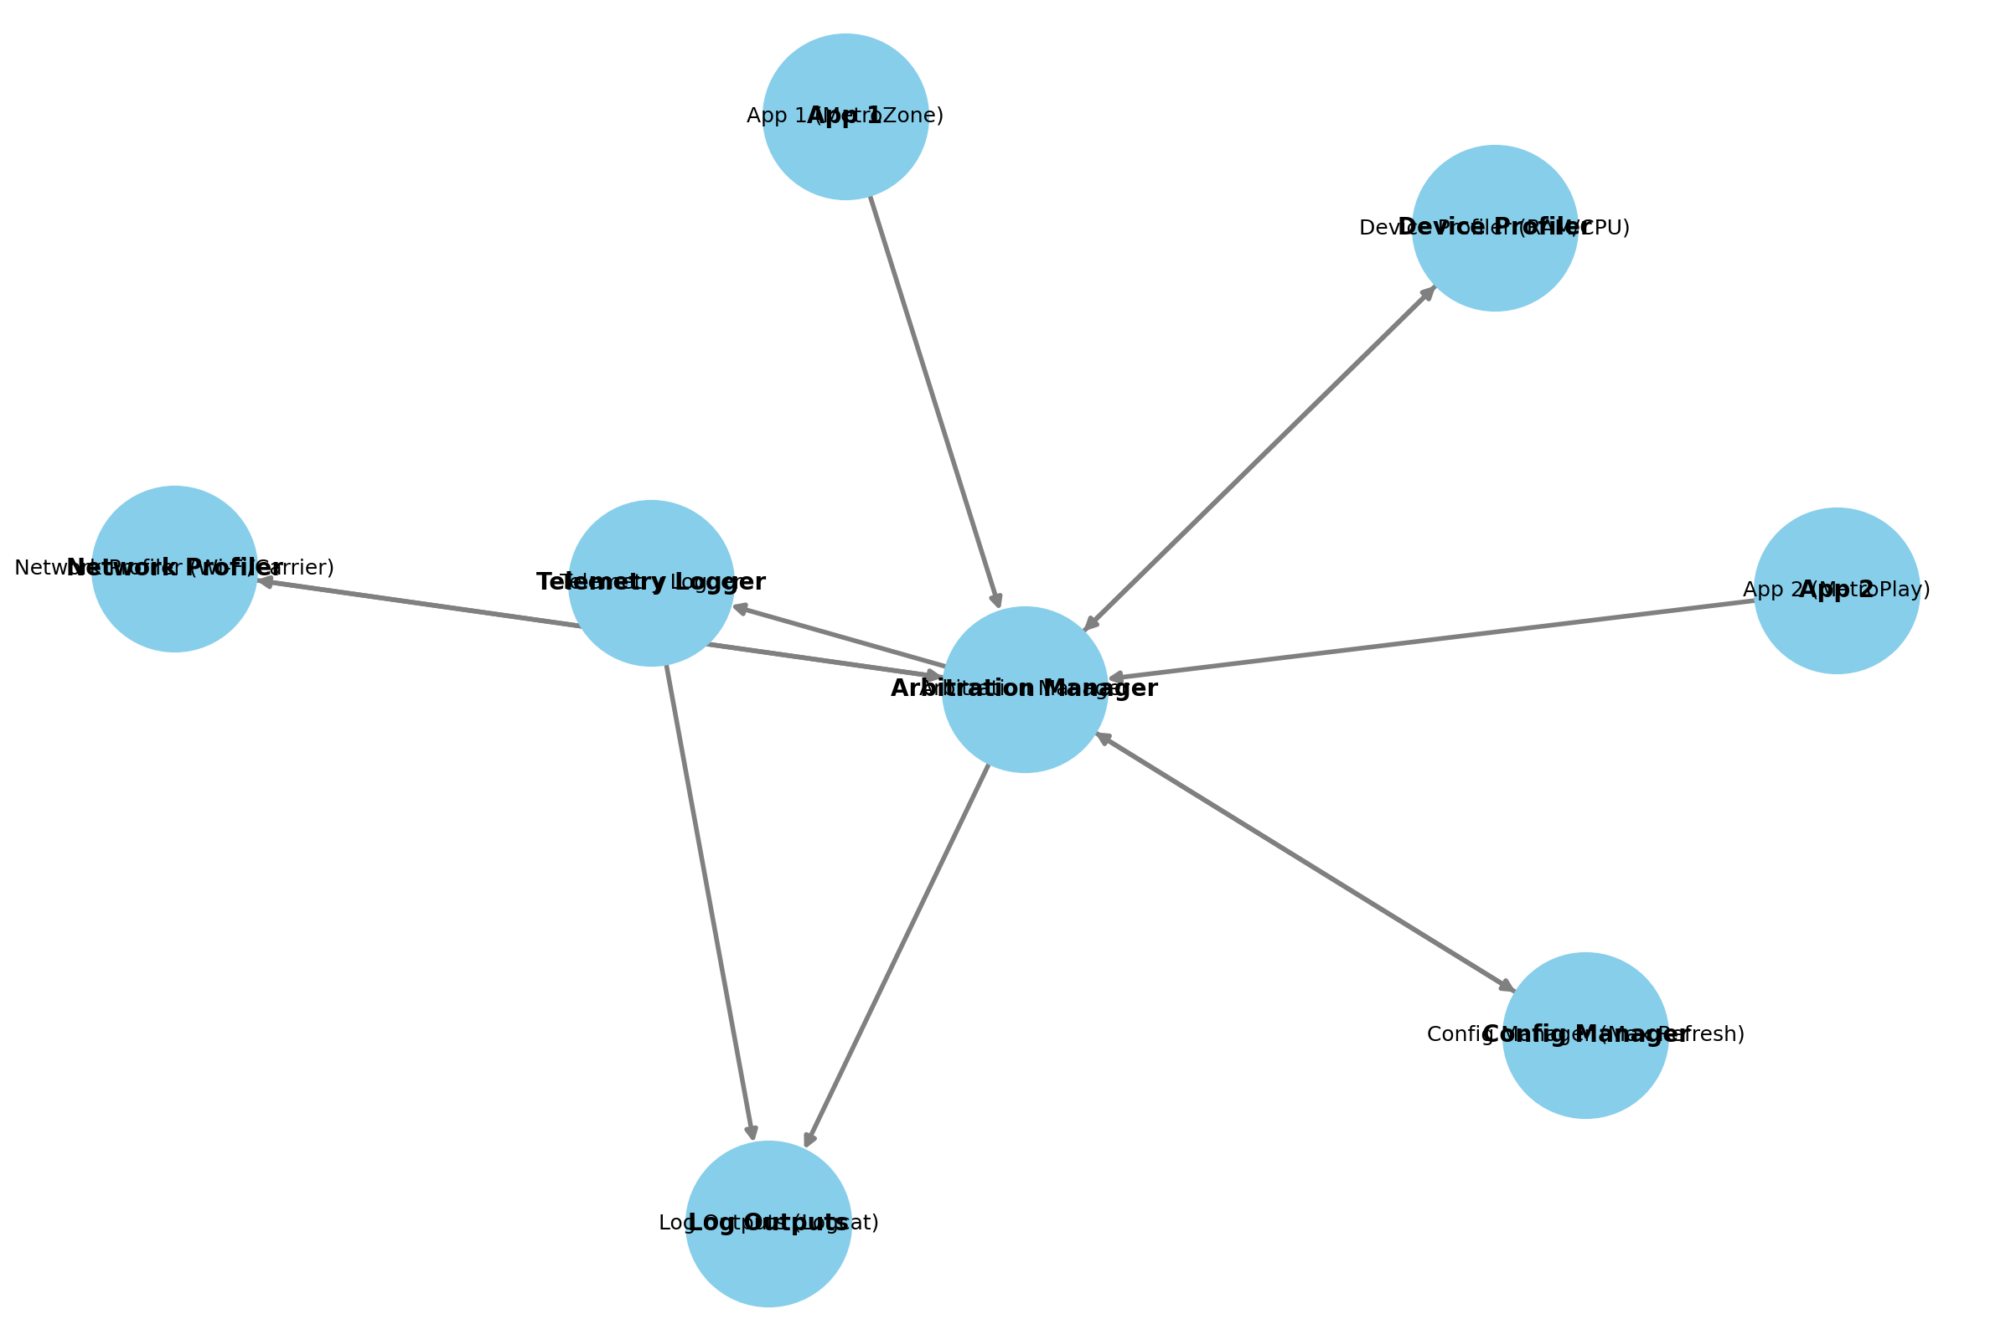

Figure 2: Arbitration Flowchart
Arbitration Flowchart: The following flowchart illustrates the decision-making process.
